From Classroom to Community: Promoting Nutrition Awareness in Khulna

In the city of Khulna, Nushrath Jahan Juhi has been working to make nutrition a more visible part of everyday learning. Her journey gained momentum after she joined GAIN’s Food Systems Youth Leadership Training of Trainers, a programme designed to help young people understand food systems and lead local solutions.
Reflecting on the experience, she said, “It did not just give us information about food systems. It helped us identify local challenges and think about community driven solutions. I learned how nutrition, education and community health are closely connected, and it encouraged me to think bigger about my role.”

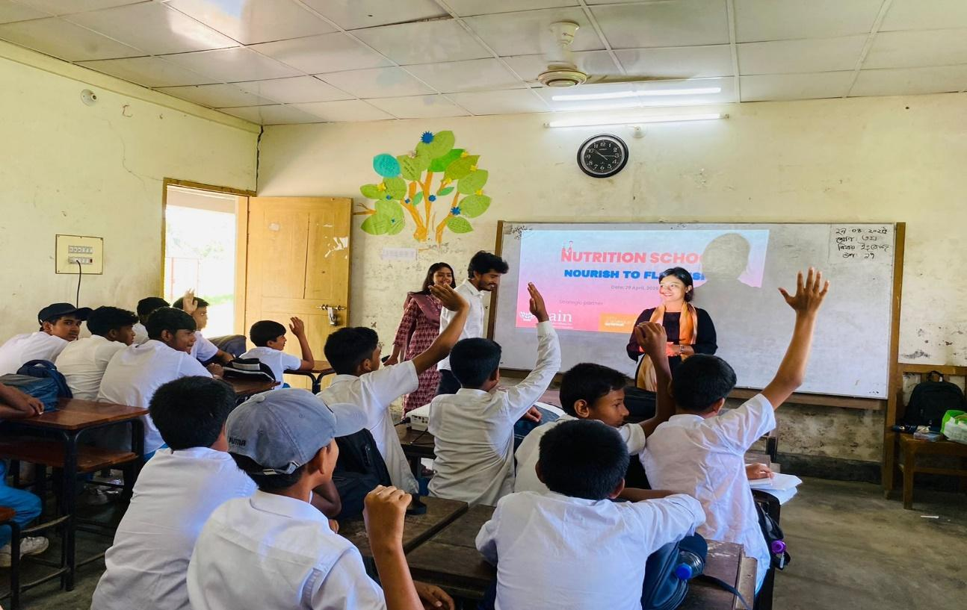

Alongside her involvement with Sun Youth Network Bangladesh, Nushrath developed skills in leadership, coordination and community engagement. These skills proved valuable when she organised a three day community training in Khulna, a region facing increasing salinity challenges. The training brought together young people and created a space for them to understand their place in the local food system. Participants included university representatives, Youth Development Officers, researchers and local leaders, allowing for meaningful discussion across different groups.
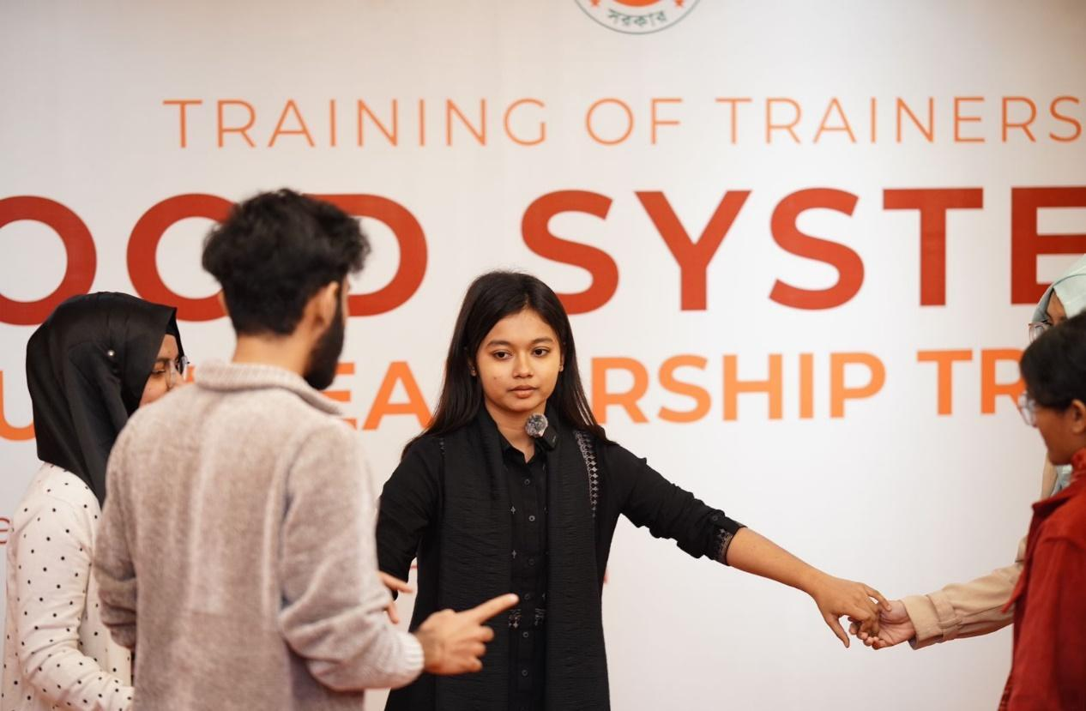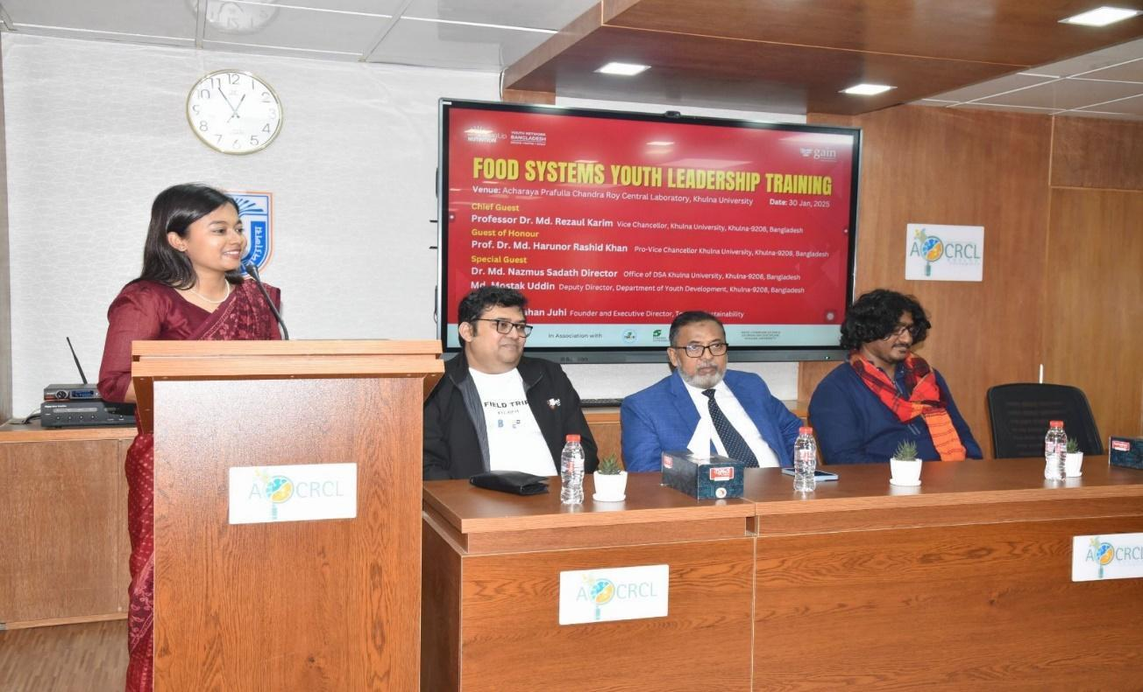
Eager to build on what she learned, Nushrath began visiting schools and community centres in Khulna. She spoke with students, teachers and parents to understand the everyday challenges adolescents face. The same pattern appeared in several schools. Students knew basic science, but many struggled to apply that knowledge to their own eating habits and wellbeing. Nutrition felt distant from their daily lives.
“During my visits after the training, I noticed that many students lacked practical nutrition knowledge. They could memorise facts, but when it came to choosing foods that support energy, focus or overall health, there was confusion or little interest. I realised that we needed to make nutrition relatable and engaging, not just a line in a textbook,” she said.
This insight led to the creation of Nutrition School, an initiative that brings learning to life through games, demonstrations and interactive activities. Instead of formal lessons, students are encouraged to participate, ask questions and connect nutrition to their own routines. Topics range from balanced diets to physical activity and mental wellbeing, all presented in a way that feels accessible to children and adolescents.
The response has been promising. Students look forward to the sessions, and teachers notice increased engagement with health topics. Building on this interest, Nushrath is now working with school authorities, education officers and the Upazila Nirbahi Officer to explore how healthy diet education can be integrated into the existing physical education curriculum. Her goal is to support long term change within the school system.
Rasel, a high school student who attended Nutrition School, shared his experience. “Before, I did not really understand how food affected my energy or focus. After attending the sessions, I see how important nutrition is for both my body and mind. I have started eating more fruits and vegetables, and I share what I learned with my friends and family.”
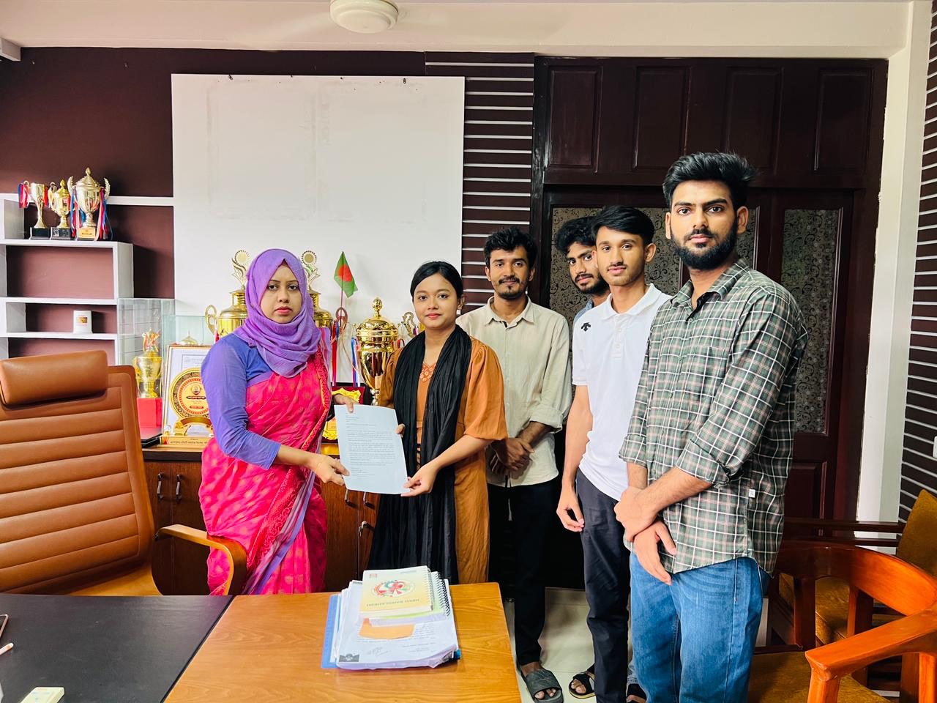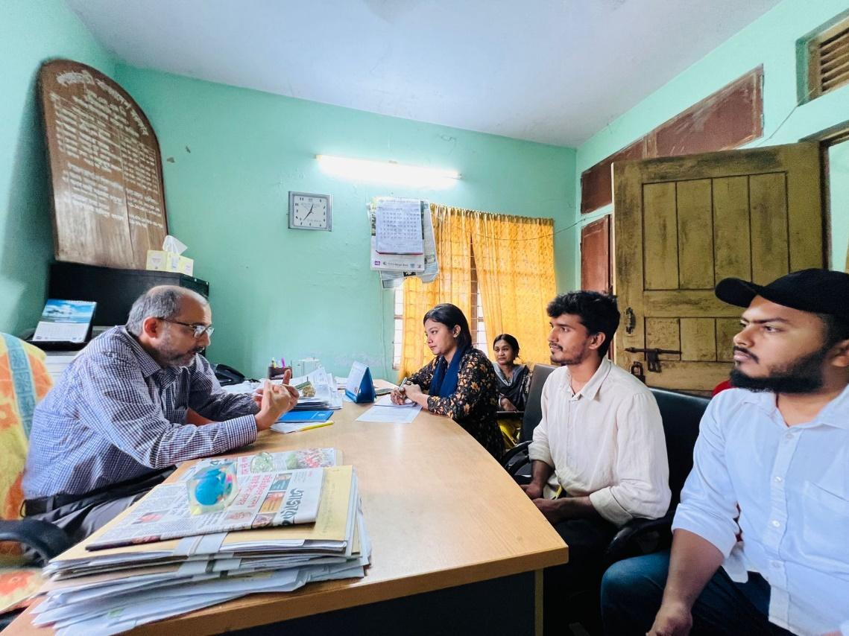
Through Nutrition School and her broader community efforts, Nushrath is helping create a shift in how young people think about food and health. Her work shows how youth leadership, supported by the right tools and training, can make nutrition education more engaging and relevant for students.
Her vision remains clear: when children understand and value nutrition, they are better prepared to take care of themselves and contribute to stronger, healthier communities.

